Bahria University,

Karachi Campus



COURSE: CS-113 COMPUTER PROGRAMMING

TERM: FALL 2022, CLASS: BSE- 1 (B)

Submitted By:

ABDULLAH

02-131222-099

_______________________________________________

(Name) (Reg. No.)

Submitted To:

Engr. Faisal / Engr. Ramsha Mashood

Signed Remarks: Score:

INDEX

|  |  |  |  |  |
| --- | --- | --- | --- | --- |
| SNO | DATE | LAB NO | LAB OBJECTIVE | SIGN |
|  |  |  |  |  |
|  |  |  |  |  |
|  |  |  |  |  |
|  |  |  |  |  |
|  |  |  |  |  |
|  |  |  |  |  |
|  |  |  |  |  |
|  |  |  |  |  |
|  |  |  |  |  |
|  |  |  |  |  |
|  |  |  |  |  |
|  |  |  |  |  |
|  |  |  |  |  |
|  |  |  |  |  |
| SNO | DATE | LAB NO | LAB OBJECTIVE | SIGN |
|  |  |  |  |  |
|  |  |  |  |  |
|  |  |  |  |  |
|  |  |  |  |  |
|  |  |  |  |  |
|  |  |  |  |  |
|  |  |  |  |  |
|  |  |  |  |  |
|  |  |  |  |  |
|  |  |  |  |  |
|  |  |  |  |  |
|  |  |  |  |  |
|  |  |  |  |  |
|  |  |  |  |  |
|  |  |  |  |  |

Bahria University,

Karachi Campus



LAB EXPERIMENT NO.

_______

**02**

LIST OF TASKS

|  |  |
| --- | --- |
| TASK NO | OBJECTIVE |
|  |  |
| 01 | Write Steps to install Visual Studio |
| 02 | Show the output of all the examples Mentioned in the lab |
| 03 | Write a program to print your profile using C# |
|  |  |
|  |  |
|  |  |
|  |  |
|  |  |
|  |  |
|  |  |
|  |  |
|  |  |
|  |  |
|  |  |

Submitted On:

____________

06/10/22

(Date: DD/MM/YY)

Task No. 01: Write step to install visual studio.

STEPS:

1. Search Virtual Studio on Internet and click on the Link as shown in picture:

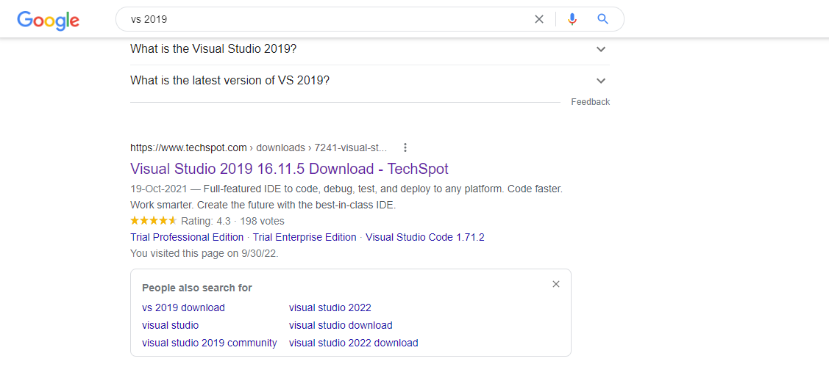

1. Click on Free Community Edition and Downloading will start:

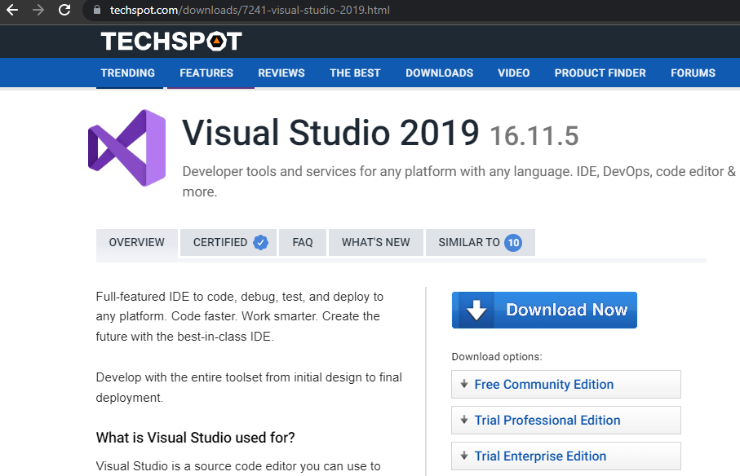

1. Now open installation package and Download Visual Studio:

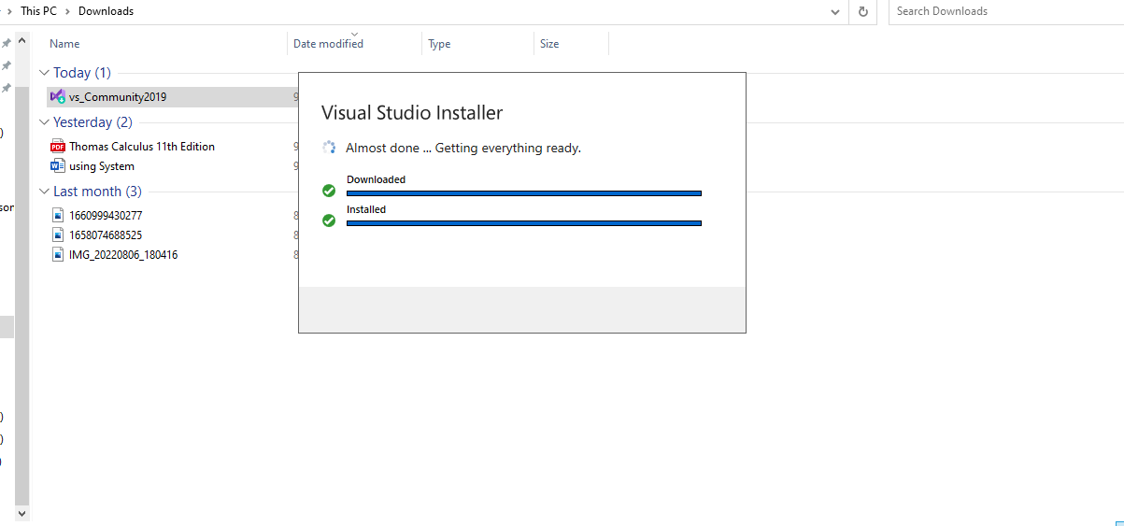

1. Now open the visual studio installer and Download .NET desktop Development:

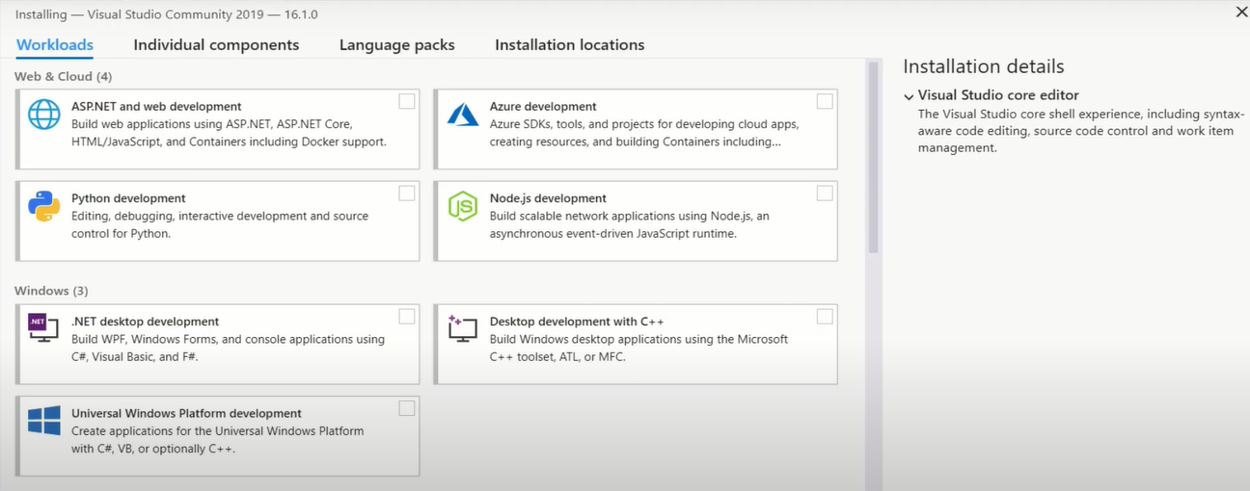

1. Visual Studio Will start automatically once it is Downloaded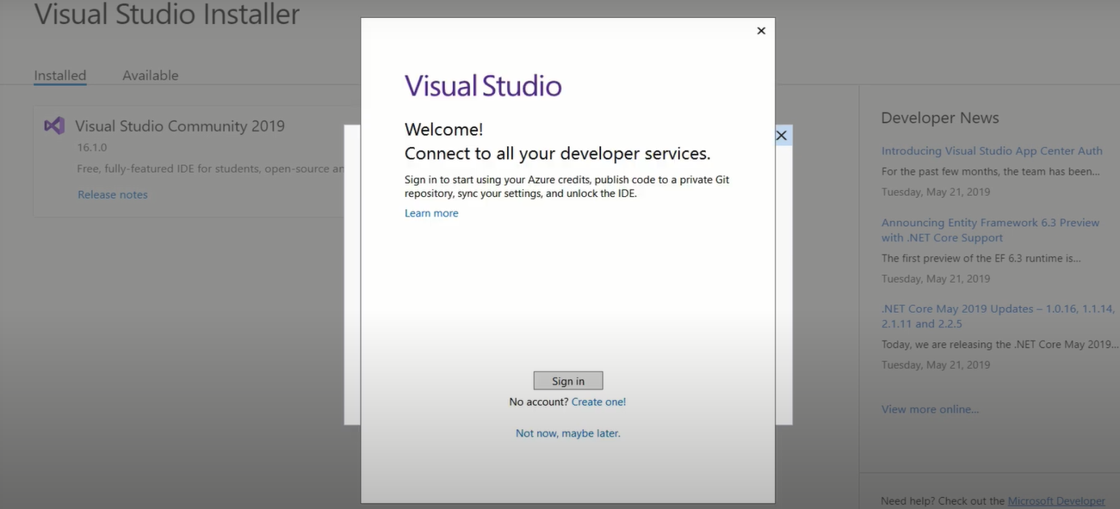

Task No. 02: Output of examples mentioned in the Lab.

Example No 01:

Solution:

using System;

namespace Abdullah_Sadiq

{

class Program

{

static void Main(string[] args)

{

Console.WriteLine("Hello World!");

}

}

}

Output:

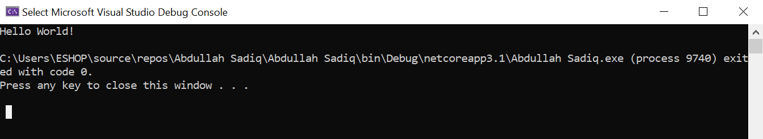

Example No 02:

Input:

using System;

namespace Example_no_02

{

class Program

{

static void Main(string[] args)

{

Console.WriteLine("Abdullah Sadiq");

Console.WriteLine("Age = 17");

Console.Write("Hobby = Photography ");

Console.Write("(Because I like it)");

}

}

}

Output: 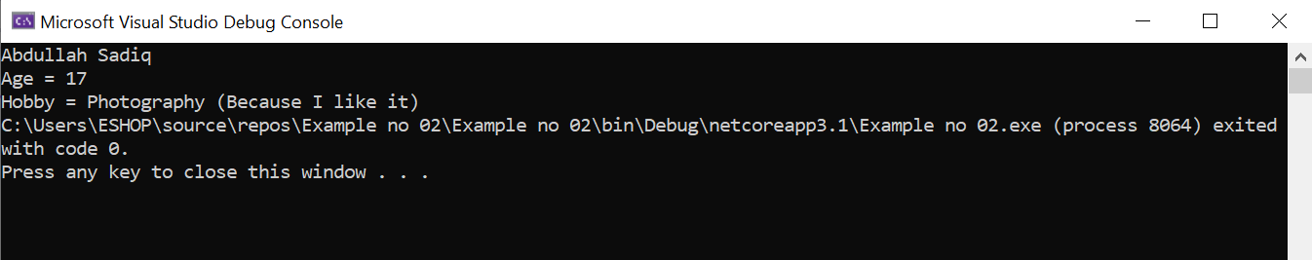

Task No. 03: Write a Program to print your Profile using C#.

Solution:

using System;

namespace Profile

{

class Program

{

static void Main(string[] args)

{

Console.WriteLine("My Profile");

Console.WriteLine(" -My name is Abdullah Sadiq.\n -My Father name is Muhammad Sadiq.\n -I am 17 year old.\n -I have done Fsc from Bahria College(NORE-1).\n -I am a student of Software Engineering at Bahria University(Karachi Campus).\n -My Hobby is Photography. I do it because I like it. ");

}

}

}

Output:

